**Ex. No:4 Roll No: 230701189**

**Date:13/08/2024 Name: Shayaan Shaikh**

WORKING WITH CONSTRAINTS

Find the Solution for the following:

1. Add a table-level PRIMARY KEY constraint to the EMP table on the ID column.The constraint should be named at creation. Name the constraint my_emp_id_pk.

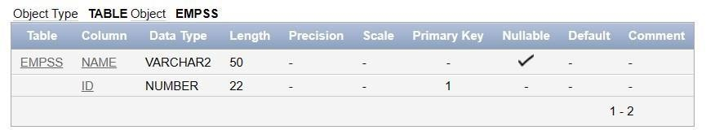**ALTER TABLE EMP ADD CONSTRAINT my_emp_id_pk PRIMARY KEY (ID);**

1. Create a PRIMAY KEY constraint to the DEPT table using the ID colum. The constraint should be named at creation. Name the constraint my_dept_id_pk.

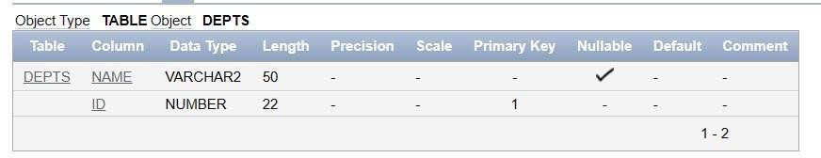**ALTER TABLE DEPT ADD CONSTRAINT my_dept_id_pk PRIMARY KEY (ID);**

1. Add a column DEPT_ID to the EMP table.

**ALTER TABLE EMPSS ADD DEPT_ID NUMBER;**

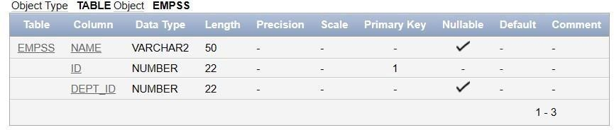

1. Add a foreign key reference on the EMP table that ensures that the employee is not assigned to nonexistent deparment. Name the constraint my_emp_dept_id_fk.

**ALTER TABLE EMPSS**

**ADD CONSTRAINT my_emp_dept_id_fk FOREIGN KEY (DEPT_ID)**

**REFERENCES DEPTS(ID);**

1. Modify the EMP table. Add a COMMISSION column of NUMBER data type, precision 2, scale 2. Add a constraint to the commission column that ensures that a commission value is greater than zero.

**ALTER TABLE EMP ADD COMMISSION NUMBER(2,2);**

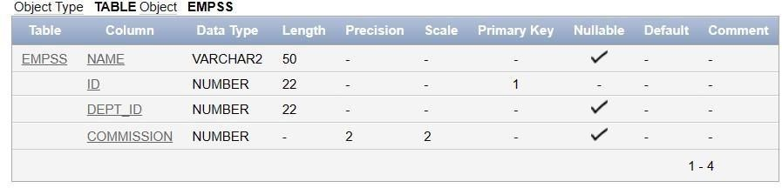

**ALTER TABLE EMP ADD CONSTRAINT chk_commission_positive CHECK (COMMISSION > 0);**

